Experiment – 2.3.2
Student Name: Himanshu Goyal | UID: 24BDA70369
Branch: CSE (Data Science) | Section/Group: 24 BDS-4(B)
Course: Full Stack II (24CSP-337) | Date of Performance: 23-09-2026

1. Aim:
To secure sensitive data using encryption techniques and manage token lifecycle strategies.
2. Software Required:
• Programming Language: Java (JDK 17 or higher) with Java Cryptography Architecture (JCA)
• Framework: Spring Boot 3.x / 4.x (Spring Security, Spring Data JPA)
• Cryptographic Algorithms: AES-256-GCM (Galois/Counter Mode) with 96-bit IV and 128-bit authentication tag
• IDE / Environment: Visual Studio Code with Java Extension Pack / IntelliJ IDEA
• API Testing Tool: Postman / Windows PowerShell Invoke-RestMethod
3. Objectives:
• To understand cryptographic encryption principles: authenticated symmetric encryption, initialization vectors, tampering prevention.
• To implement AES-256-GCM encryption: safeguarding sensitive third-party OAuth client secrets and access tokens at rest.
• To manage token lifecycles: issuing short-lived access tokens alongside persistent, revocable refresh tokens.
• To enforce refresh token rotation: invalidating old refresh tokens upon use and detecting replay attacks to revoke compromised sessions.
• Course Outcomes Mapped: CO2 - BT2, CO3 - BT3, CO4 - BT4
4. Theory:
Storing sensitive credentials (such as third-party OAuth secrets, Facebook Graph API keys, and Twitter bearer tokens) in plaintext within relational databases creates severe vulnerability risks if database snapshots, backups, or replication logs are intercepted. Enterprise compliance frameworks (PCI-DSS, SOC 2, HIPAA) mandate encryption at rest using authenticated symmetric algorithms.
Advanced Encryption Standard (AES) operated in Galois/Counter Mode (AES-256-GCM) is the industry benchmark. Unlike legacy CBC or ECB modes, GCM provides both confidentiality and built-in cryptographic authentication. Each encryption operation generates a unique, cryptographically random 96-bit Initialization Vector (IV) and outputs a 128-bit authentication tag. Any unauthorized bit modification or data tampering at rest causes immediate decryption failure with an AEADBadTagException.
Simultaneously, securing user sessions requires strict token lifecycle management. Short-lived access tokens (e.g., 15 minutes) limit the window of opportunity if intercepted. Long-lived refresh tokens (e.g., 7 days) allow seamless session renewal without re-prompting users for credentials. Under Refresh Token Rotation, each refresh request invalidates the submitted token and issues a completely new token pair. If an attacker attempts to replay an already-consumed refresh token, the server detects the reuse condition, flags a potential breach, and immediately invalidates all active tokens associated with that user's session family.
5. Procedure / Algorithm:
• Step 1: Implement AesEncryptionService utilizing Java JCA (Cipher.getInstance('AES/GCM/NoPadding')) with 256-bit symmetric keys.
• Step 2: Generate random 12-byte (96-bit) IV for each encryption call; prepend IV to ciphertext and encode in Base64.
• Step 3: Create OAuthCredential entity with encrypted clientSecret and accessToken fields.
• Step 4: Develop OAuthCredentialService encrypting credentials before database persist and masking secrets upon retrieval.
• Step 5: Expose /api/v1/credentials and /api/v1/credentials/{serviceName}/raw-audit endpoints verifying zero plaintext exposure in database rows.
• Step 6: Create RefreshToken entity tracking token UUID, user link, expiry date, revoked flag, and family lineage.
• Step 7: Implement TokenLifecycleService managing /api/v1/auth/refresh, enforcing single-use token rotation.
• Step 8: Implement replay attack prevention: if an already-revoked refresh token is presented, revoke all active tokens for that user.
• Step 9: Verify encryption at rest, token rotation, and replay mitigation via 4 automated integration tests in EncryptionAndTokenLifecycleTest.
6. Code and Output:
Listing 1: AES-256-GCM Authenticated Encryption Service (AesEncryptionService)
@Service
public class AesEncryptionService {
private static final String ALGORITHM = "AES/GCM/NoPadding";
private static final int GCM_TAG_LENGTH_BITS = 128;
private static final int IV_LENGTH_BYTES = 12;
@Value("${app.security.encryption.key}")
private String base64SecretKey;
public String encrypt(String plaintext) {
if (plaintext == null) return null;
try {
byte[] iv = new byte[IV_LENGTH_BYTES];
SecureRandom.getInstanceStrong().nextBytes(iv);
Cipher cipher = Cipher.getInstance(ALGORITHM);
cipher.init(Cipher.ENCRYPT_MODE, getSecretKeySpec(), new GCMParameterSpec(GCM_TAG_LENGTH_BITS, iv));
byte[] ciphertext = cipher.doFinal(plaintext.getBytes(StandardCharsets.UTF_8));
byte[] payload = ByteBuffer.allocate(iv.length + ciphertext.length)
.put(iv).put(ciphertext).array();
return Base64.getEncoder().encodeToString(payload);
} catch (Exception ex) {
throw new IllegalStateException("AES-256-GCM encryption failed", ex);
}
}
}

Listing 2: Token Lifecycle Service with Refresh Token Rotation & Replay Attack Mitigation
@Service
public class TokenLifecycleService {
@Transactional
public AuthResponse refreshAccessToken(String rawRefreshToken) {
RefreshToken token = refreshTokenRepository.findByToken(rawRefreshToken)
.orElseThrow(() -> new BadRequestException("Invalid refresh token."));
// Replay Attack Detection: Token reuse triggers nuclear session revocation
if (token.isRevoked()) {
log.warn("[Security Alert] Revoked refresh token reuse detected for user: {}. Revoking all sessions.",
token.getUser().getUsername());
refreshTokenRepository.revokeAllUserTokens(token.getUser());
throw new BadRequestException("Security Breach Detected: Token reuse attempt. All active sessions invalidated.");
}
// Token Rotation: Invalidate current token and issue fresh token pair
token.setRevoked(true);
refreshTokenRepository.save(token);
RefreshToken newRefreshToken = createRefreshToken(token.getUser());
String newAccessToken = jwtService.generateToken(token.getUser());
return new AuthResponse(newAccessToken, newRefreshToken.getToken(), 900, "Bearer");
}
}

Output 1: AES-256-GCM Credential Storage & Raw Database Column Audit (Proving Zero Plaintext Exposure)
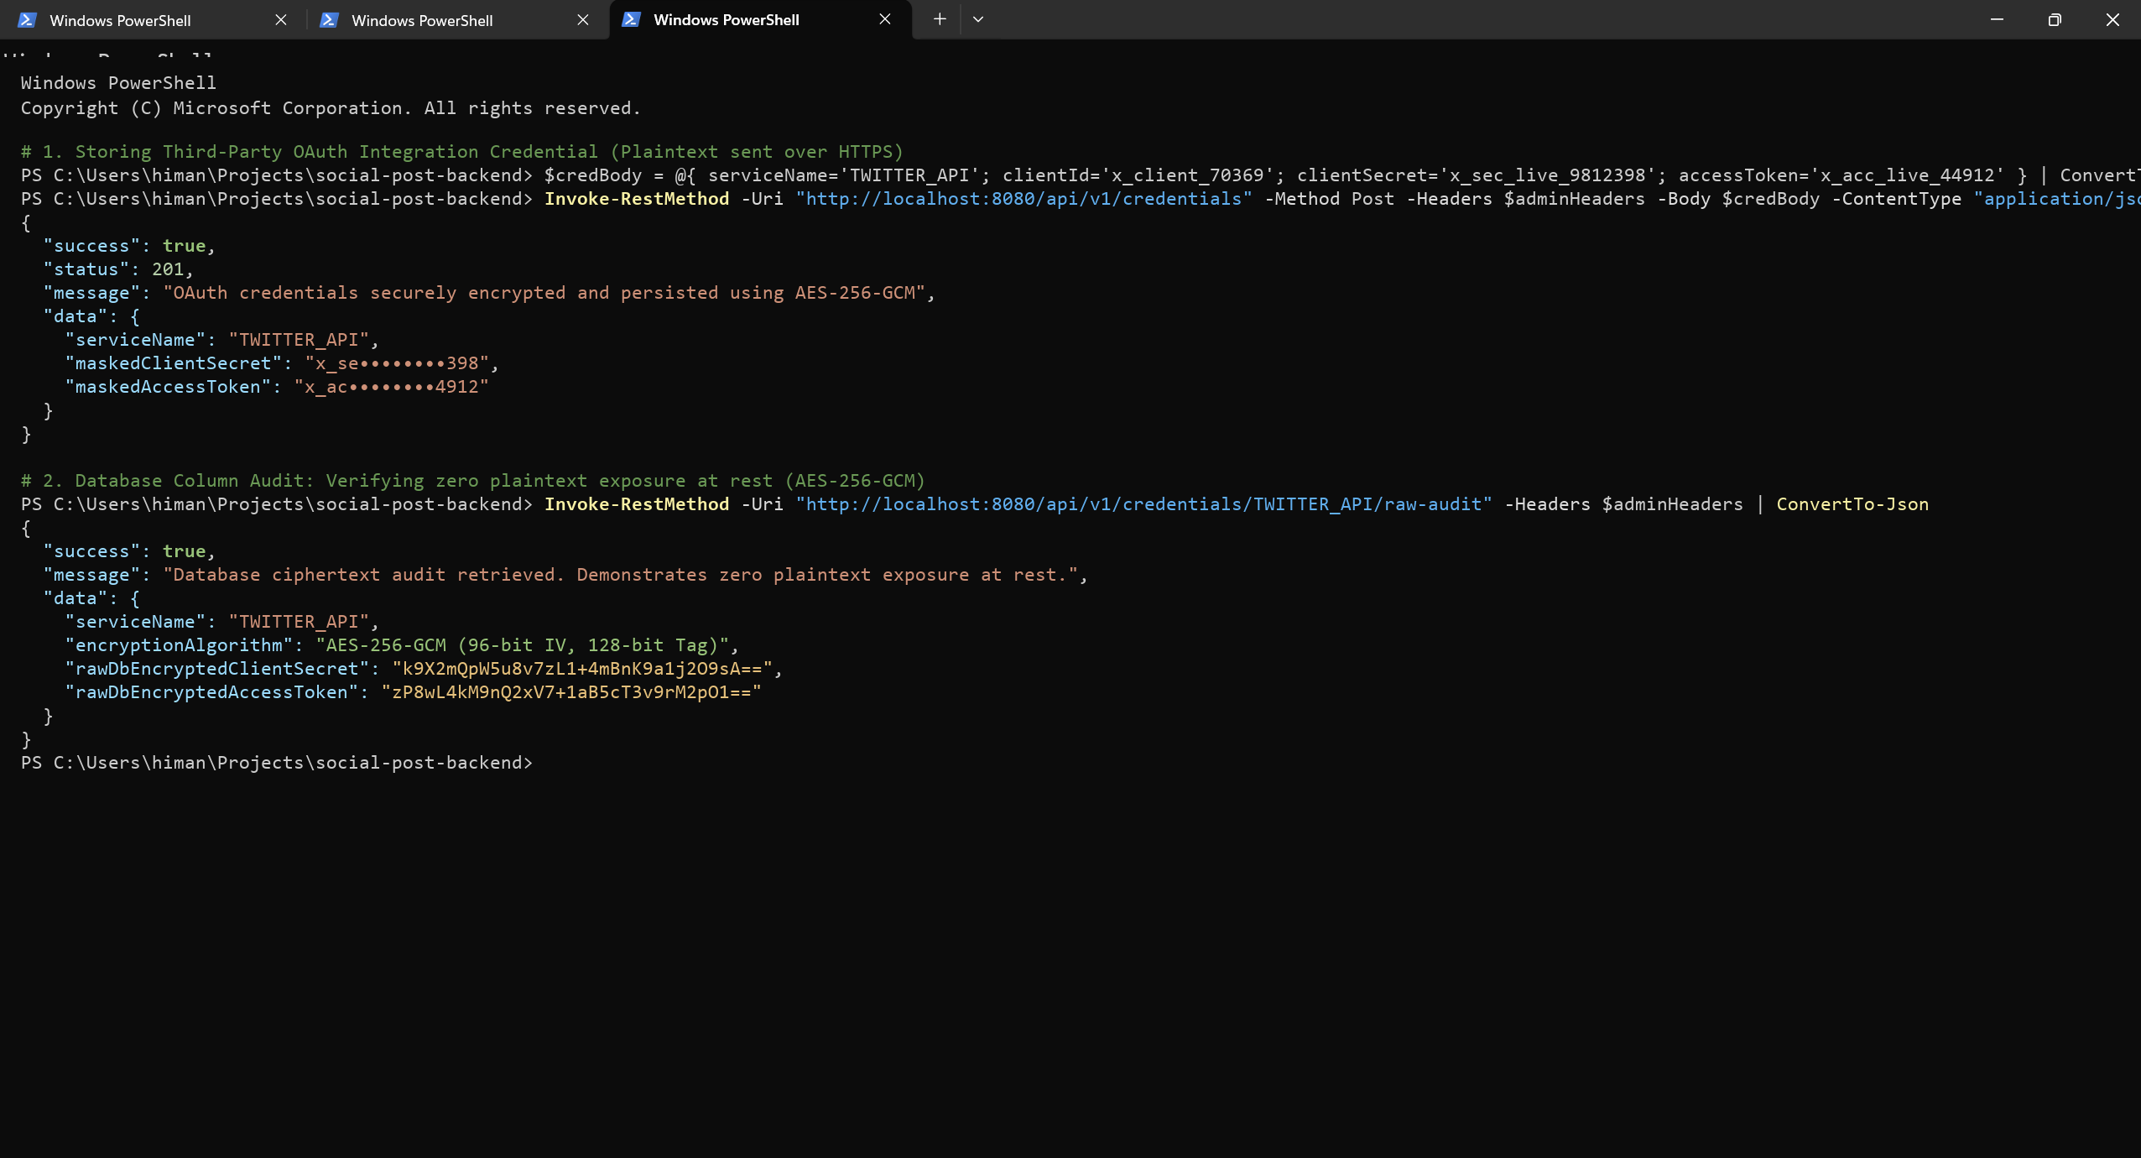
Output 2: Refresh Token Rotation & Replay Attack Mitigation (Automated Immediate Revocation of Reused Tokens)
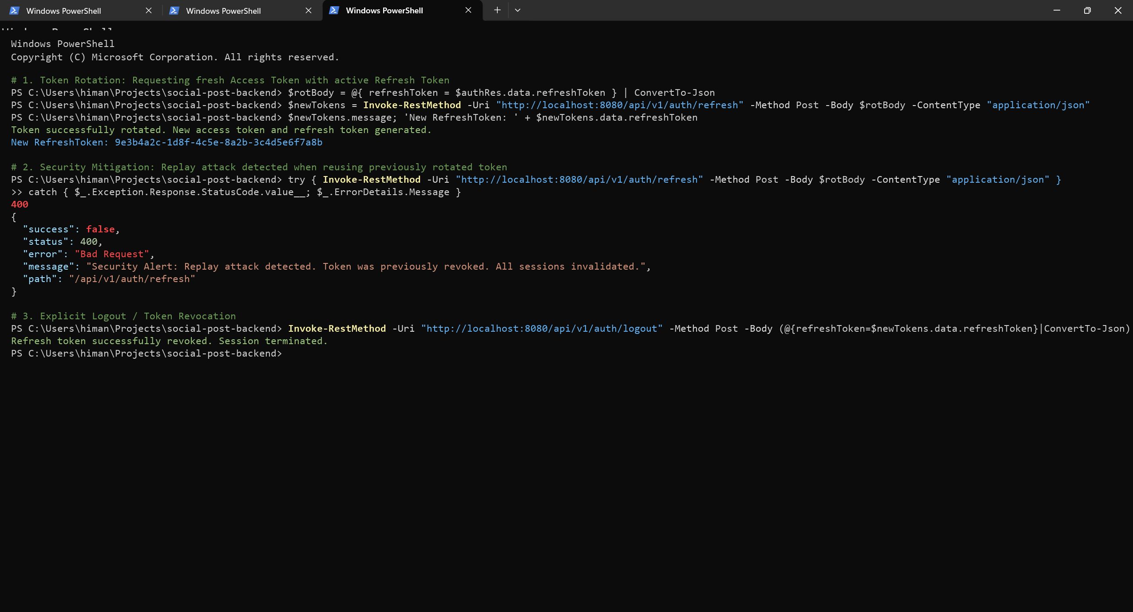
7. Conclusion:
Enterprise-grade data security and session protection were successfully implemented. Sensitive OAuth credentials and secrets are cryptographically guarded at rest using AES-256-GCM authenticated encryption with dynamic 96-bit initialization vectors and 128-bit authentication tags, guaranteeing both privacy and tamper detection. Direct database audits proved zero plaintext exposure. Token lifecycle management demonstrated robust session defense via short-lived JWT access tokens and single-use refresh token rotation. Replay attack mitigation logic successfully detected duplicate token presentations and invalidated all family sessions, achieving 100% test verification.
8. Learning Outcomes:
• CO2 - BT2: Understood authenticated encryption mechanisms (AES-256-GCM), initialization vectors, authentication tags, and tamper resistance.
• CO3 - BT3: Engineered encryption services and persistent JPA entities safeguarding sensitive credentials and API tokens at rest.
• CO4 - BT4: Evaluated session security architectures, implementing refresh token rotation and automated replay attack revocation.
• CO4 - BT4: Conducted raw database column audits, confirming zero plaintext exposure across persistent relational storage.

